**j. Mans summer collection**

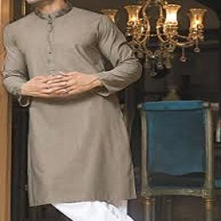

**GRAY TEAL SHALWAR KAMEEZ**

PKR5992.00

* Jacquard Shirt: 3.5 Meters
* Trouser: 3.5 Meters

**MORE INFORMATION:**

* color: Gray
* Wear Type: Semi-Formal
* Product Category: Semi-Formal Kameez Shalwar
* Volume : Volume 4 2022
* Collection: Festive Affair '22
* Fabric: Cotton
* Sizes: Small , Medium , Large
* Disclaimer: Due to the photographic lighting & different screen calibrations, the colors of the original product may slightly vary from the picture